# ANDROID ANALOG CLOCK AND DIGITAL CLOCK

The **android.widget.AnalogClock** and **android.widget.DigitalClock** classes provides the functionality to display analog and digital clocks.

Android analog and digital clocks are used to show time in android application. Android AnalogClock is the subclass of View class.

Android DigitalClock is the subclass of TextView class. Since Android API level 17, it is

*deprecated*. You are recommended to use **TextClock** Instead.

The AnalogClock was deprecated in API level 23. This widget is no longer supported. Instead if you want to use AnalogClock in your application you need to hard code. It does not appear in API level 27 to drag from palette.

In android, you need to drag analog and digital clocks from the pallet to display analog and digital clocks.

***activity_main.xml***

Now, drag the analog and digital clocks, now the xml file will look like this. File: activity_main.xml

<?xml version="1.0" encoding="utf-8"?>

<android.support.constraint.ConstraintLayout xmlns:android="<http://schemas.android.com/apk/res/an> droid"

xmlns:app="[http://schemas.android.com/apk/res-auto"](http://schemas.android.com/apk/res-auto) xmlns:tools="[http://schemas.android.com/tools"](http://schemas.android.com/tools) android:layout_width="match_parent" android:layout_height="match_parent" tools:context="example.javatpoint.com.analogdigital.MainActivity">

<AnalogClock android:id="@+id/analogClock1" android:layout_width="wrap_content" android:layout_height="wrap_content" android:layout_alignParentTop="true" android:layout_centerHorizontal="true" android:layout_marginLeft="136dp" android:layout_marginTop="296dp" app:layout_constraintStart_toStartOf="parent" app:layout_constraintTop_toTopOf="parent" />

<DigitalClock android:id="@+id/digitalClock1" android:layout_width="wrap_content"

android:layout_height="wrap_content" android:layout_below="@+id/analogClock1" android:layout_centerHorizontal="true" android:layout_marginLeft="176dp" android:layout_marginTop="84dp" android:text="DigitalClock" app:layout_constraintStart_toStartOf="parent" app:layout_constraintTop_toTopOf="parent" />

</android.support.constraint.ConstraintLayout>

***Activity class***

We have not write any code here.

File: MainActivity.java

package example.javatpoint.com.analogdigital; import android.support.v7.app.AppCompatActivity; import android.os.Bundle;

public class MainActivity extends AppCompatActivity { @Override

protected void onCreate(Bundle savedInstanceState) { super.onCreate(savedInstanceState); setContentView(R.layout.activity_main);

}

}

***Output:***

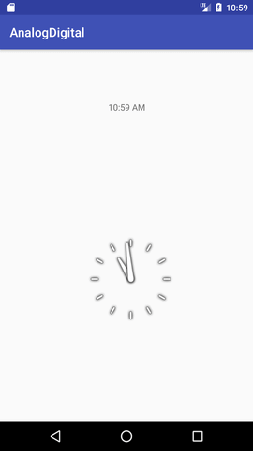

### TASK 1:

Develop an android application to have an analog clock as the above example. [10]

### TASK 2:

Develop an android application to display a digital clock on an activity. [10]

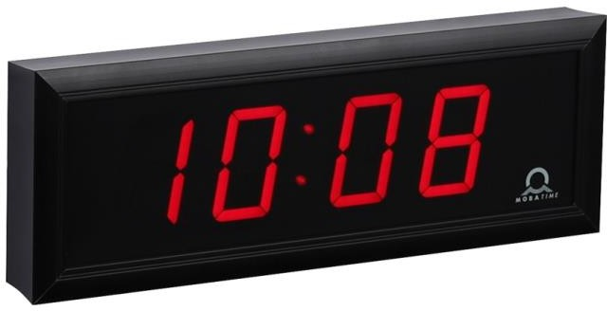

##### RESOURCES:

<https://www.codingconnect.net/mobile-application-development-lab/> <https://www.javatpoint.com/android-tutorial> <https://www.tutorialspoint.com/android> <https://developer.android.com/guide> [Https://developer.Android.com/training/basics/firstapp/creating-project](https://developer.android.com/training/basics/firstapp/creating-project)

[Https://www.raywenderlich.com/120177/beginning-Android-development-tutorial-](https://www.raywenderlich.com/120177/beginning-Android-development-tutorial-installingAndroid-studio) [installingAndroid-studio](https://www.raywenderlich.com/120177/beginning-Android-development-tutorial-installingAndroid-studio) <https://www.youtube.com/playlist?list=PLS1QulWo1RIbb1cYyzZpLFCKvdYV_yJ-E> [Https://www.udemy.com/java-tutorial/](https://www.udemy.com/java-tutorial/)

[Https://www.w3schools.com/xml/](https://www.w3schools.com/xml/) [Http://www.Androidguys.com/](http://www.androidguys.com/)